Snoring Problem Statement:

Snoring:

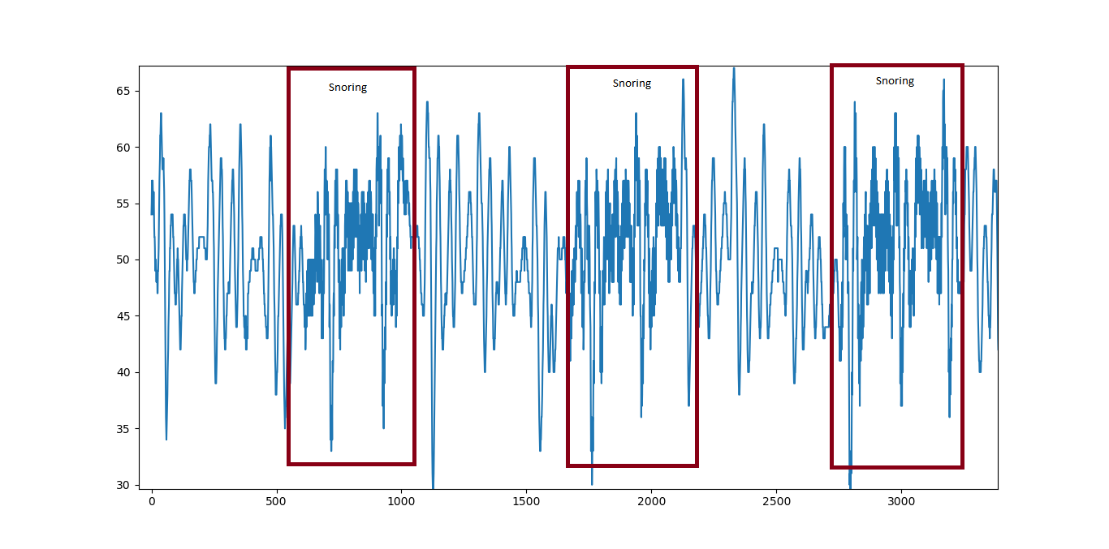

Without Snoring-

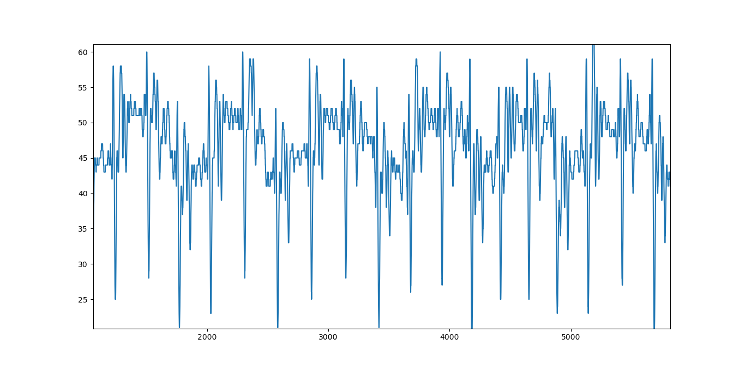

1. Initially data with snoring and without snoring was observed.(Data collection)
2. For snoring,it was observed there was many closely related points.Time frame was 600 points.(Feature Extraction)
3. Time frame of 600 points was taken and the total number of closely related points was calculated.
4. If the total number of closely related points is greater than 5,then there is Snoring otherwise there is no Snoring.